SyniqAI Data Ingestion & Transformation System - PostgreSQL

MTAI’S Malaysia Sovereign Ai (LLM)


PostgreSQL Ingestion

Version 1.0

DOCUMENTATION CONTROL

Item | Details
Title | Data Ingestion & Transformation System
Connector Focus | PostgreSQL Connector (Low-Latency, High-Throughput)
Version | 1.0
Author (s) | - Syarifah Fajriyah Nasrin
Date | 28/01/2026
Purpose of Documentation | - This Technical System Design (TSD) documents the architecture, internal design decisions, libraries, concurrency model, and performance optimizations of the PostgreSQL Ingestion Pipeline.

Prepared By:
Syarifah
SYARIFAH FAJRIYAH NASRIN,
AI ENGINEER INTERN

Table of Contents

1. Introduction 3
1.1 Executive Summary 3
1.2 The Crucible - Early Setbacks & Strategic Pivots 4
1.3 Glossary of Terms & Acronyms 4
2. System Overview – Product Behaviour & Capabilities 5
2.1 How the System Behaves 5
2.2 Architectural Design Principles 5
2.3 Explicit non-goals 6
3. System Architecture 6
3.1 High-Level Architecture 6
3.2 Architectural Design Principles 7
4. Functional Specification 7
4.1 Ingestion Configuration 7
4.1.1 Configuration Schema 8
4.1.2 Sample Configuration 8
4.2 Adaptive Resource Logic 8
4.3 Technical Implementation 9
4.3.1 Data Flow Strategy 9
4.3.2 Concurrency Model 9
4.3.3 Schema Resilience & Drift Handling 9
4.4 Bronze Layer Specification 10
4.5 Silver Transformation Engine 10
5. Technical Specification 11
5.1 Technology Stack 11
5.2 Component Breakdown 11
5.3 Data Flow Architecture 11
5.4 Concurrency & Performance Model 12
5.5 Schema Handling Strategy 12
6. Security & Data Privacy 12
6.1 Credential Management 12
6.2 Network & Access Controls 12
6.3 Data Integrity & Auditability 12
7. Deployment, Rollout & Rollback 13
7.1 Deployment Strategy 13
7.2 Rollout Strategy 13
8. Key Performance Metrics (KPIs) 13
9. Project Timeline 14
10. Conclusion & Roadmap 14
Appendix A 15
Environmental Setup & Operational Prerequisites 15

Introduction

Executive Summary
The SyniqAI Data Ingestion & Transformation System – PostgreSQLSystem is a Python-based data ingestion framework designed to reliably extract large volumes of relational data and persist them into a Parquet-based for structured and relational data with low latency, high throughput, and strong operational safety guarantees.
To support enterprise-scale workloads, the PostgreSQL Connector implements connection pooling, adaptive chunk sizing, intelligent parallel extraction, and built-in safety valves. By combining intelligent parallel extraction, connection pooling, adaptive chunk sizing, and bounded backpressure, the system achieves a 2.3× end-to-end performance improvement while maintaining strict memory safety and deterministic outputs.
Special emphasis is placed on schema survival. PostgreSQL itself is structured, but JSONB columns frequently contain nested objects and arrays with inconsistent shapes. The system is explicitly engineered to survive these patterns without crashing, silently corrupting schemas, or losing lineage.

The Crucible - Early Setbacks & Strategic Pivots
The initial iterations of the PostgreSQL ingestion pipeline followed a conventional, serial extraction model. While functionally correct, this approach quickly revealed structural weaknesses when applied to non-trivial data volumes. Execution time scaled linearly, connection setup costs dominated runtime, and memory usage became unpredictable as datasets grew.
Early stress testing exposed three critical failure modes:
- Throughput Collapse under large tables due to single-threaded extraction.
- Connection Overhead caused by repeated database handshakes.
- Memory Pressure from unbounded in-memory buffering during write slowdowns.

This crucible phase fundamentally shaped the system’s design philosophy:
performance gains must never come at the cost of stability, determinism, or schema safety. Every subsequent design decision from adaptive chunk sizing to bounded queues was informed by these early lessons.

Glossary of Terms & Acronyms

Bronze Layer | The raw, immutable storage layer containing ingested data exactly as extracted, with minimal transformation and full metadata.
Silver Layer | A curated dataset derived from Bronze, with controlled schema normalization and optional enrichment.
CDC | Change Data Capture; a mechanism to track row-level changes in source systems.
Chunk | A bounded subset of rows retrieved from the source database in a single fetch operation.
Connector | A source-specific ingestion module responsible for extraction logic.
JSONB | PostgreSQL binary JSON data type supporting nested semi-structured data.
Lineage | Metadata describing the origin, schema, and execution context of a dataset.
Parquet | A columnar, compressed, analytics-optimized file format.
Producer–Consumer | A concurrency pattern where data producers and consumers operate asynchronously via a shared buffer.
Run ID | A unique identifier representing a single ingestion execution.
Schema Drift | A change in source data structure over time.
Watermark | A column-based marker (e.g., timestamp or ID) used for incremental extraction.

System Overview – Product Behaviour & Capabilities

How the System Behaves

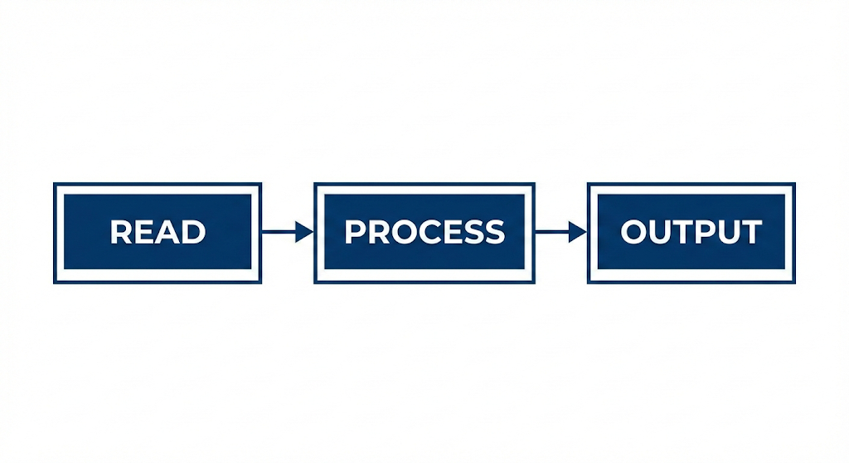
The system always follows a deterministic three-stage flow:
Figure 2.1: Core Stages of the System

- Producers extract data from PostgreSQL using pooled connections and parallel workers.
- Consumers persist sanitized data to disk as Parquet files.
- A bounded queue enforces backpressure between the two stages.

This separation ensures predictable throughput and prevents memory exhaustion under load. Data is streamed from the source database and never fully materialized in memory. Each execution produces both a data artifact and a corresponding metadata artifact. Failures are treated as terminal events and are surfaced immediately; partial or silent failures are not permitted. Schema changes are never applied implicitly.

Architectural Design Principles

The system supports ingestion of relational PostgreSQL tables, including those containing JSONB columns with nested objects and arrays. It supports full refresh, incremental, and watermark-based extraction modes. Execution strategy (serial versus parallel) is selected automatically based on dataset size and system heuristics.

- Separation of Concerns
Database I/O (network-bound) is decoupled from disk I/O (storage-bound).

- Backpressure by Design
A bounded queue ensures slow consumers automatically throttle producers.

- Deterministic Outputs
Each run produces immutable data artifacts and metadata.

- Fail-Fast Safety
Partial or silent failures are not permitted; errors are surfaced immediately.

Explicit non-goals
The system does not automatically explode array structures, infer business semantics, perform destructive schema changes in the Bronze layer, or operate without generating metadata. These constraints are intentional and aligned with data governance requirements.

System Architecture

High-Level Architecture
The ingestion pipeline is implemented using an asynchronous Producer–Consumer model:
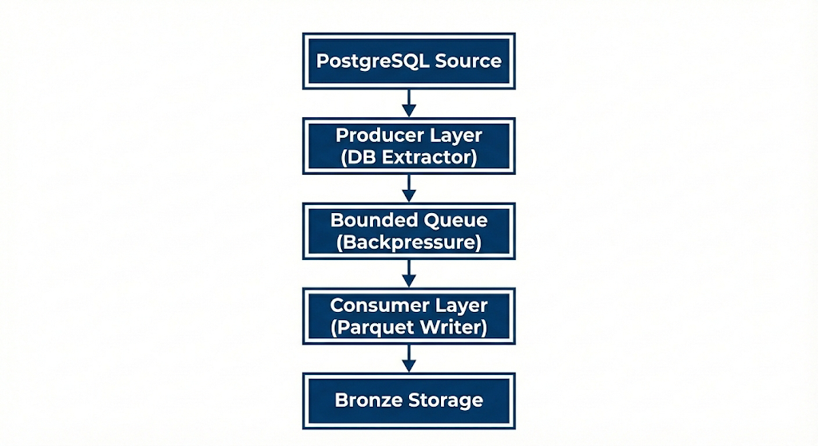
Figure 3.1: High-Level Architecture Diagram of System Architecture

This design decouples database I/O from disk I/O, enabling predictable throughput and controlled memory usage.

Architectural Design Principles
The architecture adheres to established engineering principles:
separation of concerns, backpressure to prevent resource exhaustion, deterministic outputs, and explicit schema handling. Safety mechanisms are embedded to disable parallelism when it would degrade performance or stability.

Functional Specification

Ingestion Configuration
Ingestion behavior is fully defined through a configuration file. This acts as a contract between the user and the system.

Input: The user defines a config.json containing database credentials, target entity (table), and extraction strategy (Full/Incremental).

Configuration Schema
Parameter | Data Type | Required | Description
Source_type | String | Yes | The database dialect (e.g., postgresql, mysql, oracle).
Connection | Object | Yes | Connection parameters. Note: Secrets must rely on environment variable references.
Connection.host | String | Yes | The hostname or IP address of the source.
Connection.port | Integer | Yes | The source port (e.g., 5432).
Target_entity | String | Yes | The specific table or view to ingest (e.g., public.users).
Extraction_mode | String | Yes | Strategy for ingestion. Allowed values: snapshot, incremental.

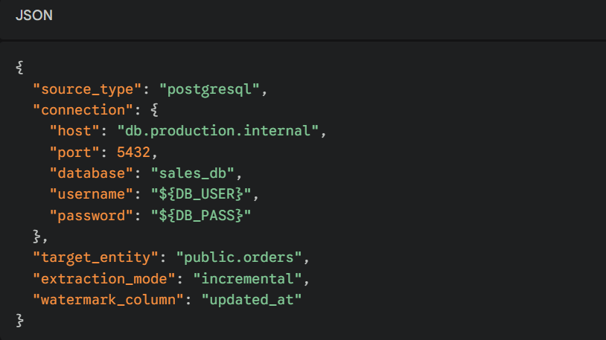
Sample Configuration

Adaptive Resource Logic
The system performs runtime resource assessment before extraction:
- RAM Awareness
If available memory < 4GB, chunk sizes are reduced from 50k to 20k rows to prevent memory pressure.

- Data Volume Awareness
Tables with fewer than 1,000 rows automatically downgrade to serial execution, avoiding parallelism overhead.

These safety valves ensure the system adapts to its execution environment rather than relying on static tuning.

Technical Implementation

Data Flow Strategy
READ
- ThreadPoolExecutor for parallel extraction
- SQLAlchemy connection pooling eliminates repeated TCP handshakes

PROCESS
- Schema snapshotting prior to ingestion
- JSONB objects and arrays are deterministically serialized
- No implicit flattening or schema mutation in Bronze

OUTPUT
- Parquet files written via PyArrow
- Snappy compression enforced for fast writes and compact storage

Concurrency Model
A bounded queue.Queue(maxsize=5) sits between producers and the writer thread.
- If the writer slows down, producers block automatically
- This prevents unbounded memory growth
- Ensures system stability even under high throughput

Schema Resilience & Drift Handling
- Schemas are captured at run start and stored as metadata
- Nested JSON and arrays are serialized rather than exploded
- Schema changes are surfaced explicitly wnever applied implicitly
- This guarantees ingestion continuity without silent corruption

Bronze Layer Specification
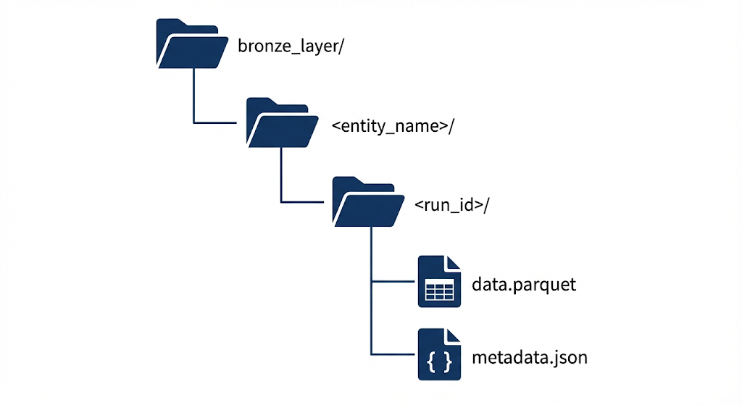
Each ingestion run produces:

Bronze guarantees preserves source fidelity, columnar parquet (Snappy-compressed), schema-safe writes and immutable, versioned outputs.

Silver Transformation Engine
Transformation from Bronze to Silver (first form) is an explicit, opt-in process. The Silver engine performs controlled normalization, selective flattening of nested objects, and optional deduplication while preserving array structures unless explicitly configured otherwise.

Technical Specification

Technology Stack
The system is implemented using Python 3.10+.

Core Libraries:
- pandas & sqlalchemy: Vectorized data fetching.
- pyarrow: Columnar memory management and Parquet writing.
- concurrent.futures: Thread management.
- psycopg2: Low-level PostgreSQL driver.
- tkinter: GUI Toolkit.

Component Breakdown
- The Orchestrator (main.py)
Acts as the traffic controller. It enhances the user configuration (e.g., calculating optimal worker counts based on CPU cores) and initializes the writer_worker thread before starting extraction.

- The Connector (postgres_connector.py)
Implements the Smart Parallelism logic:
- Queries MIN(id) and MAX(id) to determine the "Data Universe".
- Splits this universe into N non-overlapping ranges.
- Spawns workers to fetch these ranges simultaneously.
- Safety Valve: If total_range < 1000, it downgrades to Serial Mode.

- ParquetSink – thread-safe persistence
A thread-safe class responsible for disk I/O.
- Locking: Uses threading.Lock() to ensure that even if multiple writers existed, the file pointer wouldn't be corrupted.
- Compression: Enforces snappy compression for high-speed writes.

Data Flow Architecture
- Read: Connectors fetch DataFrame chunks (50k rows).
- Sanitize: Complex types (Dict/List) are JSON-dumped to strings.
- Buffer: Chunks are pushed to a bounded Queue.
- Write: The Worker Thread pulls chunks, verifies they aren't empty, and writes to Parquet.

Concurrency & Performance Model
Parallel extraction is conditionally enabled based on dataset characteristics. Chunk sizes are adaptively tuned to available memory. Empty or invalid chunks are explicitly guarded to prevent runtime failures.

Schema Handling Strategy
Schemas are snapshotted prior to extraction. Semi-structured fields are serialized deterministically. Arrays are preserved by default to avoid irreversible transformations.

Security & Data Privacy

Credential Management
- No Hardcoding: The SecretManager class enforces security.
  - Priority 1: Environment Variables / Config (CI/CD friendly).
  - Priority 2: getpass.getpass for interactive secure entry.
- Credentials are never logged to the console or text files.

Network & Access Controls
- Connection Pooling: Reduces the frequency of authentication exchanges, minimizing the attack surface.
- SCRAM-SHA-256: The system supports modern PostgreSQL authentication methods as defined in the pg_hba.conf configuration.

Data Integrity & Auditability
Every dataset is accompanied by metadata describing schema, execution context, and runtime statistics. Output paths are deterministic and versioned by run ID.

Key Performance Metrics (KPIs)
System health and success are measured through throughput, end-to-end runtime, startup latency, execution success rates, and observed schema drift.

Metric | Old Architecture | New Architecture (Parallel) | Improvement
Total Runtime (1M Rows) | 35.6 Seconds | 15.4 Seconds | 2.3x Speedup
Throughput | ~28,000 rows/sec | ~65,000 rows/sec | +132% Increase
Startup Latency | 30s (Default Config) | 7s (Tuned Config) | 4x Faster Start
Connection Cost | ~150ms / task | ~0.05ms (Pooled) | Instant Reuse
Memory Stability | Unbounded | Auto-Scaling (Safe) | 0 Crashes

Analysis:
The shift to connection pooling reduced per-task connection costs from ~150ms to ~0.05ms. Combined with conditional parallelism, this architectural change is the primary driver behind the observed 132% throughput increase and 2.3× runtime reduction.

Project Timeline
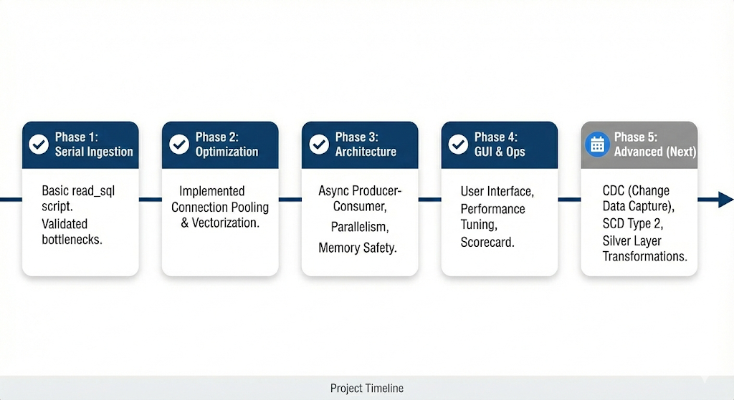

Conclusion & Roadmap
The SyniqAI PostgreSQL Ingestion System provides a secure, schema-resilient, and high-performance foundation for enterprise data platforms. Future enhancements include CDC integration, additional source connectors, and support for slowly changing dimensions.

Appendix A

Environmental Setup & Operational Prerequisites
This appendix defines the required environment configuration, dependencies, and access prerequisites necessary to deploy and operate the SyniqAI PostgreSQL Ingestion System.

A.1 System Requirements
Operating System
- Linux (Ubuntu 20.04+ recommended) or Windows 10/11

Runtime
- Python 3.10 or higher

Hardware (Minimum)
- RAM: 4 GB (adaptive throttling enabled below this threshold)
- CPU: 4 logical cores
- Disk: SSD recommended for Parquet write throughput

A.2 Python Dependencies
Install required dependencies using pip:
pip install pandas sqlalchemy psycopg2-binary pyarrow psutil

A.3 Environment Variable Configuration
All credentials must be provided via environment variables or secure runtime input. Hardcoded secrets are explicitly disallowed.

- Required Environment Variables
export PG_HOST=your_postgres_host
export PG_USER=your_username
export PG_PASSWORD=your_password
On Windows (PowerShell):
setx PG_HOST "your_postgres_host"
setx PG_USER "your_username"
setx PG_PASSWORD "your_password"

The system resolves credentials in the following order:

- Environment variables (preferred)
- Secure interactive prompt (getpass) if variables are missing

A.4 PostgreSQL Server Configuration (Remote Access)
To enable remote ingestion, the PostgreSQL server must allow inbound connections from the ingestion host.

Step 1: Identify Ingestion Host IP
On the ingestion machine:
ipconfig # Windows
ifconfig # Linux

Step 2: Update postgresql.conf
Enable listening on external interfaces:
listen_addresses = '*'

Step 3: Update pg_hba.conf
Allow authenticated access from the ingestion host:
host all all 0.0.0.0/0 scram-sha-256

Security Note:
In production environments, replace 0.0.0.0/0 with a restricted CIDR range.

Step 4: Restart PostgreSQL Service
sudo systemctl restart postgresql
(or restart via Services on Windows)

A.5 Network & Firewall Requirements
- PostgreSQL port (default: 5432) must be reachable from the ingestion host
- Firewalls must allow outbound TCP traffic to the database server
- No inbound ports are required on the ingestion machine

A.6 Configuration Artifact Deployment
Place the ingestion configuration file (config.json) alongside the application entrypoint.
Example directory structure:

project_root/
├── main.py
├── postgres_connector.py
├── parquet_sink.py
├── config.json

The system validates configuration completeness at startup and fails fast if required fields are missing.

A.7 Execution & Runtime Behaviour
To execute the ingestion pipeline:
python main.py
During execution:
- Schema is snapshotted before extraction
- Resource limits are assessed dynamically
- Progress and errors are streamed to the Execution Console
- Output artifacts are written to the Bronze Layer directory

A.8 Output Verification
Each successful run produces:

- One or more Parquet data files
- A metadata.json file containing:
  - Schema snapshot
  - Row counts
  - Execution timestamps
  - Runtime statistics
  - Run ID

Operators should verify the presence of both artifacts before promoting data downstream.

A.9 Failure Handling & Safe Restarts
- Any extraction failure results in immediate termination
- Partial data is not promoted as successful output
- Re-execution with the same configuration produces a new run_id
- Previous runs remain immutable and available for rollback

A.10 Operational Notes
- Disk retention policies should be enforced externally (e.g., archive or delete Bronze folders older than X days)
- Dependency versions should be reviewed quarterly for security updates
- Connection pooling parameters may be tuned for high-latency networks if required

